Used OneHotEncoderEstimator, StringIndexer MinMaxScaler to transform multiple columns, returning a one-hot-encoded output vector column for each input column. It is common to then merge these vectors into a single feature vector using VectorAssembler.

Normalized and scaled numerical data, transformed categorical data into binary sparse vector.

Normalization such as z-score techniques, center, decimal, and unitSum were used.

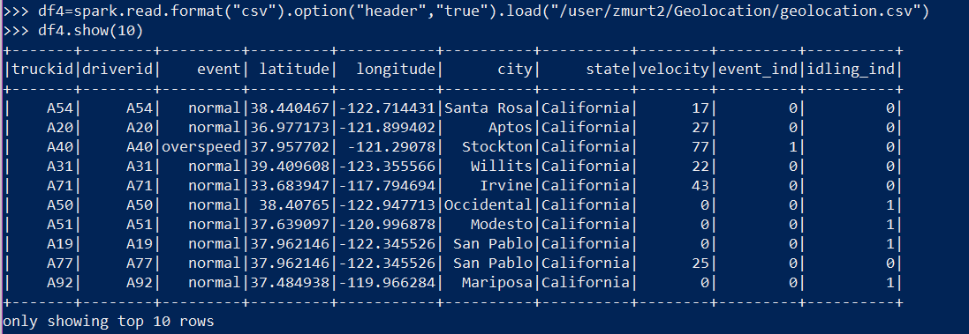





Transforming Velocity data into float-type:





